THYROID DISEASE CLASSIFICATION USING ML

SUBMITTED BY

TEAM LEADER

V.uma

TEAM MEMBERS

R.vinodha

Y.suvasini

K.thamizharasi

**Project Description:**

The Thyroid gland is a vascular gland and one of the most important organs of the human body. This gland secretes two hormones which help in controlling the metabolism of the body.

The two types of Thyroid disorders are Hyperthyroidism and Hypothyroidism. When this disorder occurs in the body, they release certain types of hormones into the body which imbalances the body’s metabolism. A thyroid-related Blood test is used to detect this disease but it is often blurred and noise will be present. Data cleansing methods were used to make the data primitive enough for the analytics to show the risk of patients getting this disease. Machine Learning plays a very deciding role in disease prediction. Machine Learning algorithms, SVM - support vector machine, Random Forest Classifier, XGB Classifier and ANN - Artificial Neural Networks are used to predict the patient’s risk of getting thyroid disease. The web app is created to get data from users to predict the type of disease.

**Technical Architecture:**

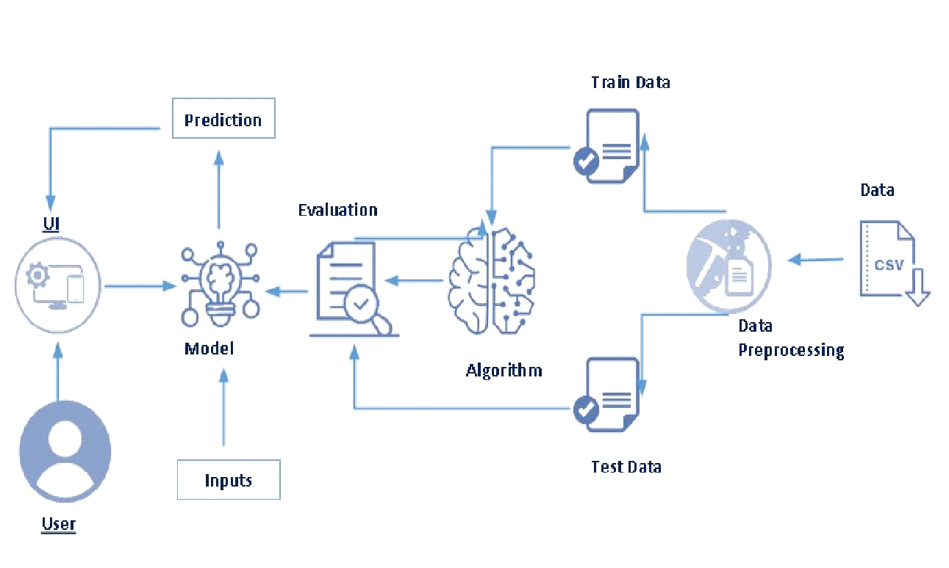

**Project Flow:**

* The user interacts with the UI to enter the input.
* Entered input is analysed by the model which is integrated.
* Once the model analyses the input the prediction is showcased on the UI

To accomplish this, we have to complete all the activities listed below,

* Define Problem / Problem Understanding
  + Specify the business problem
  + Business requirements
  + Literature Survey
  + Social or Business Impact.
* Data Collection & Preparation
  + Collect the dataset
  + Data Preparation
* Exploratory Data Analysis
  + Descriptive statistical
  + Visual Analysis
* Model Building
  + Training the model in multiple algorithms
  + Testing the model
* Performance Testing & Hyperparameter Tuning
  + Testing model with multiple evaluation metrics
  + Comparing model accuracy before & after applying hyperparameter tuning
* Model Deployment
  + Save the best model
  + Integrate with Web Framework
* Project Demonstration & Documentation
  + Record explanation Video for project end to end solution
  + Project Documentation-Step by step project development procedure

**Project Structure:**

Create the Project folder which contains files as shown below

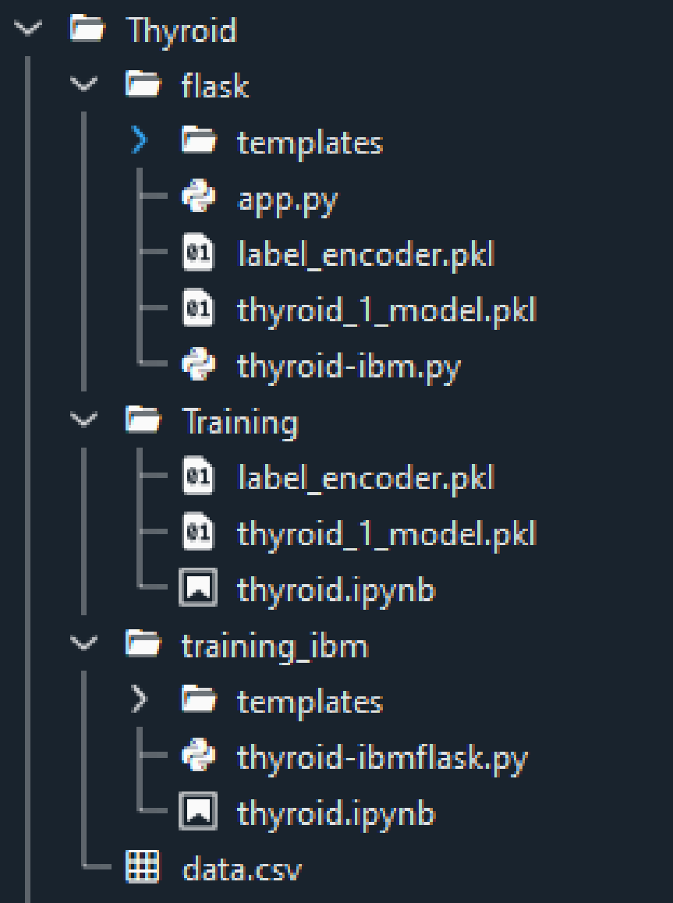

* We are building a flask application which needs HTML pages stored in the templates folder and a python script app.py for scripting.
* thyroid_1_model.pkl is our saved model. Further, we will use this model for flask integration.
* Training folder contains model training files and the training_ibm folder contains IBM deployment files.

### Define Problem / Problem Understanding

In this milestone, we will go through the problem understanding.

**Specify The Business Problem**

The Thyroid gland is a vascular gland and one of the most important organs of the human body. This gland secretes two hormones which help in controlling the metabolism of the body.

 The two types of Thyroid disorders are Hyperthyroidism and Hypothyroidism. When this disorder occurs in the body, they release certain types of hormones into the body which imbalances the body’s metabolism. A thyroid-related Blood test is used to detect this disease but it is often blurred and noise will be present. Data cleansing methods were used to make the data primitive enough for the analytics to show the risk of patients getting this disease. Machine Learning plays a very deciding role in disease prediction. Machine Learning algorithms, SVM - support vector machine, Random Forest Classifier, XGB Classifier and ANN - Artificial Neural Networks are used to predict the patient’s risk of getting thyroid disease. The web app is created to get data from users to predict the type of disease.

### Business Requirements

The business requirements for a machine learning model to predict thyroid disease include the ability to accurately predict thyroid disease based on the scan results, Minimise the number of false positives (wrong thyroid disease confirmations) and false negatives (thyroid is there but got as not thyroid disease). Provide an explanation for the model's decision, to comply with regulations and improve transparency.

**Literature Survey**

The thyroid gland is one of the body’s most visible endocrine glands. Its size is determined by the individual’s age, gender, and physiological states, such as pregnancy or lactation. It is divided into two lobes (right and left) by an isthmus (a band of tissue). It is imperceptible in everyday life yet can be detected when swallowing. The thyroid hormones T4 and T3 are needed for normal thyroid function. These hormones have a direct effect on the body’s metabolic rate. It contributes to the stimulation of glucose, fatty acid, and other molecule consumption. Additionally, it enhances oxygen consumption in the majority of the body’s cells by assisting in the processing of uncoupling proteins, which contributes to an improvement in the rate of cellular respiration. Thyroid conditions are difficult to detect in test results, and only trained professionals can do so. However, reading such extensive reports and predicting future results is difficult. Assume a machine learning model can detect the thyroid disease in a patient. The thyroid disease can then be easily identified based on the symptoms in the patient’s history. Currently, models are evaluated using accuracy metrics on a validation dataset that is accessible.

**Social Or Business Impact**

Social Impact:- Untreated/undetected thyroid disease is more dangerous at times it can lead to fatal of the person. So, we can detect it at the earliest then people can get treatment and get cured.

Business Model/Impact:- We can make this application public, offer services as a subscription based or can collaborate with healthcare centres or specialists.

**Data Collection & Preparation**

ML depends heavily on data. It is the most crucial aspect that makes algorithm training possible. So this section allows you to download the required dataset.

**Importing The Libraries**

Import the necessary libraries as shown in the image.

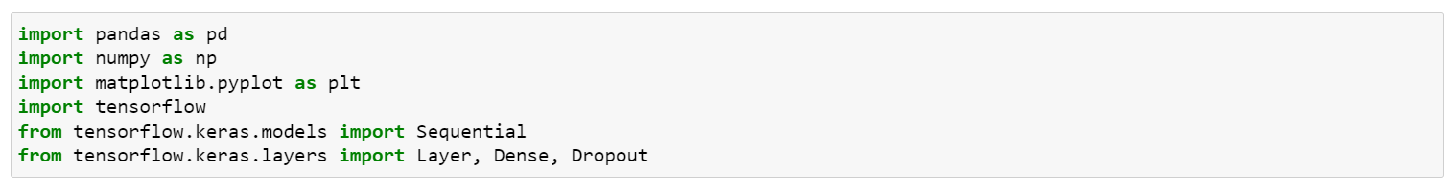

**Read The Dataset**

Our dataset format might be in .csv, excel files, .txt, .json, etc. We can read the dataset with the help of pandas.

In pandas, we have a function called read_csv() to read the dataset. As a parameter, we have to give the directory of the csv file.

**Data Pre-Processing**

As we have understood how the data is, let's pre-process the collected data.

The download data set is not suitable for training the machine learning model as it might have so much randomness so we need to clean the dataset properly in order to fetch good results. This activity includes the following steps.

* Handling missing values
* Descriptive analysis
* Splitting the dataset as x and y
* Handling Categorical Values
* Checking Correlation
* Converting Data Type
* Splitting dataset into training and test set
* Handled Imbalanced Data
* Applying StandardScaler

Note: These are the general steps of pre-processing the data before using it for machine learning. Depending on the condition of your dataset, you may or may not have to go through all these steps.

**Checking For Null Values**

For checking the null values, data.isnull() function is used. To sum those null values we use the .sum() function to it. From the below image we found that there are no null values present in our dataset. So we can skip handling the missing values step.

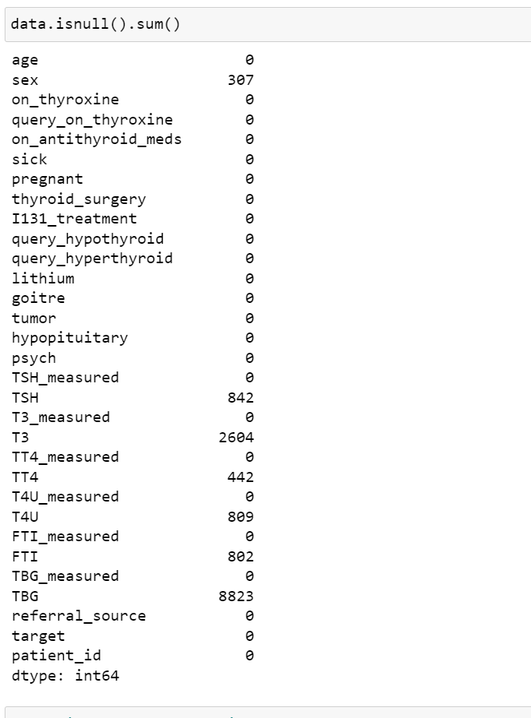

Removing the Redundant attributes from the dataset.

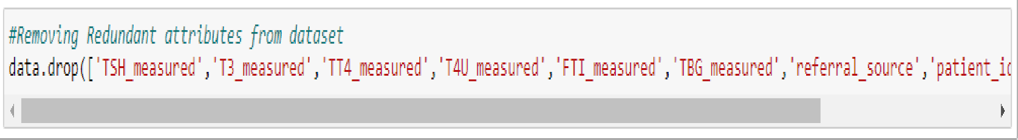

Re-mapping the 'target' values to the diagnostic Group

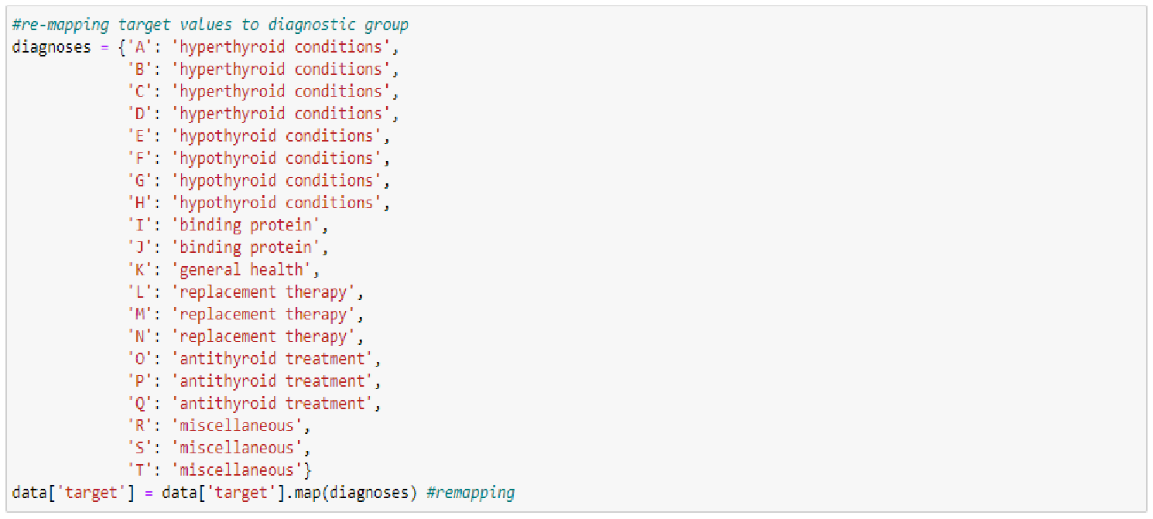

Dropping Null Values

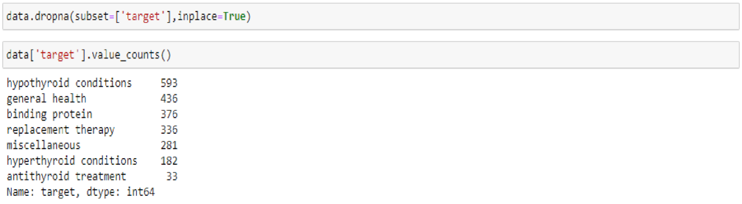

Checking the 'age' is there any above 100 and we drop the age>100.

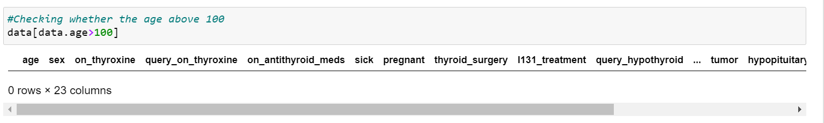

**Splitting The Data X And Y**

Splitting the data x and y



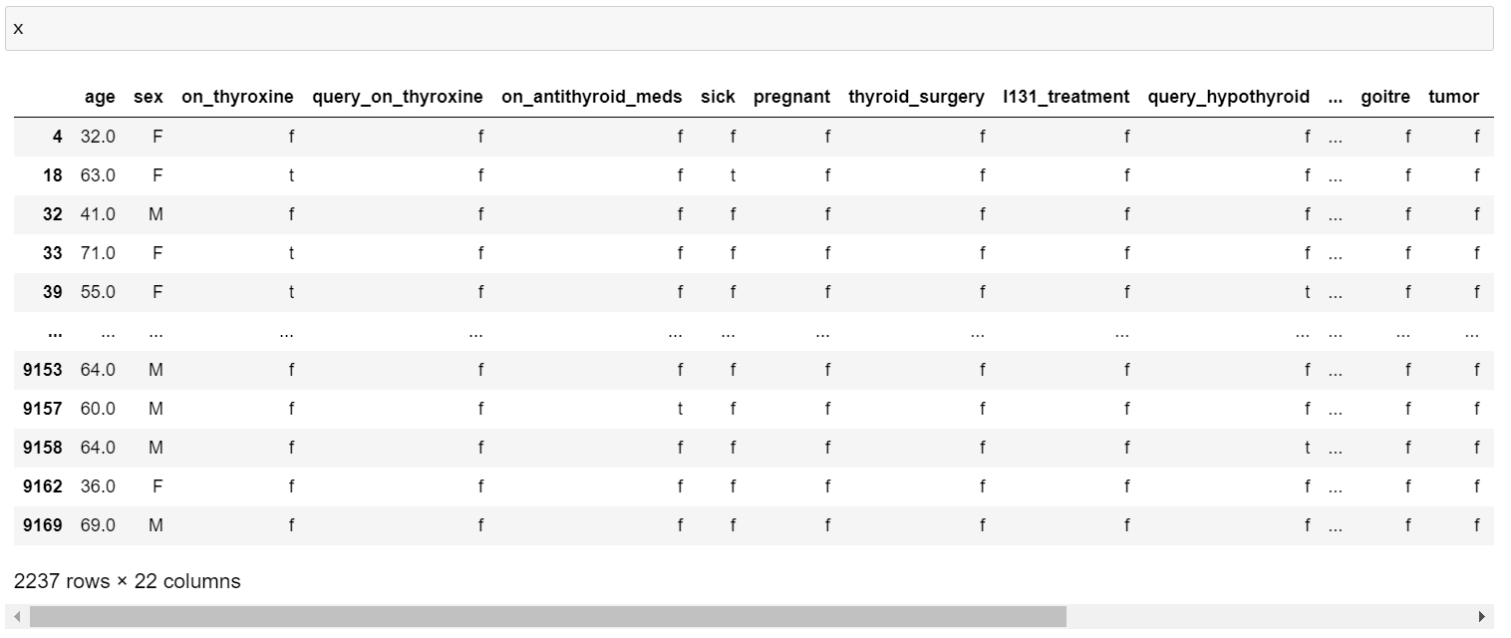

Making 'F' on wherever we have the 'nan' values on data.

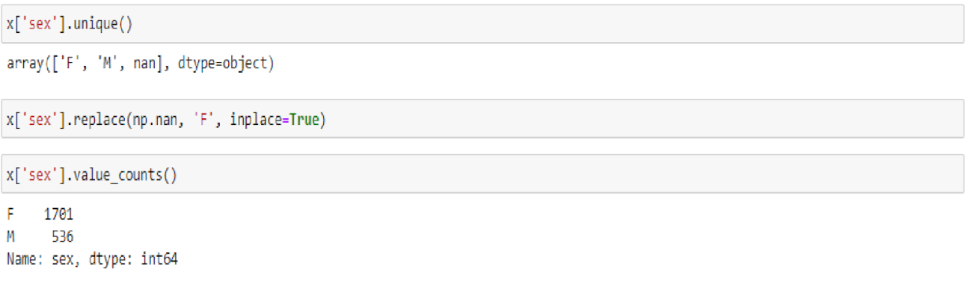

**Converting The Data Type**

Here, we have the object values are  'TSH', 'T3', 'TT4', 'T4U', 'FTI', 'TBG' and convert them to float values.

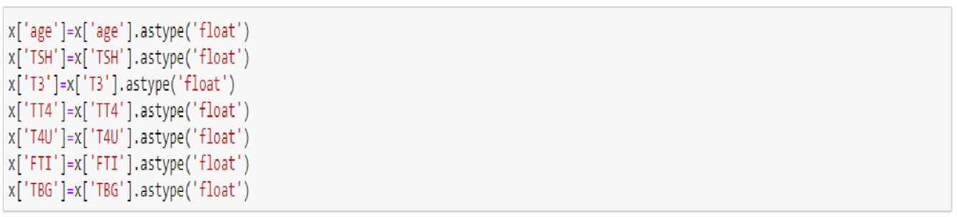

Then we can check the datatype information about the dataset by code of x.info()

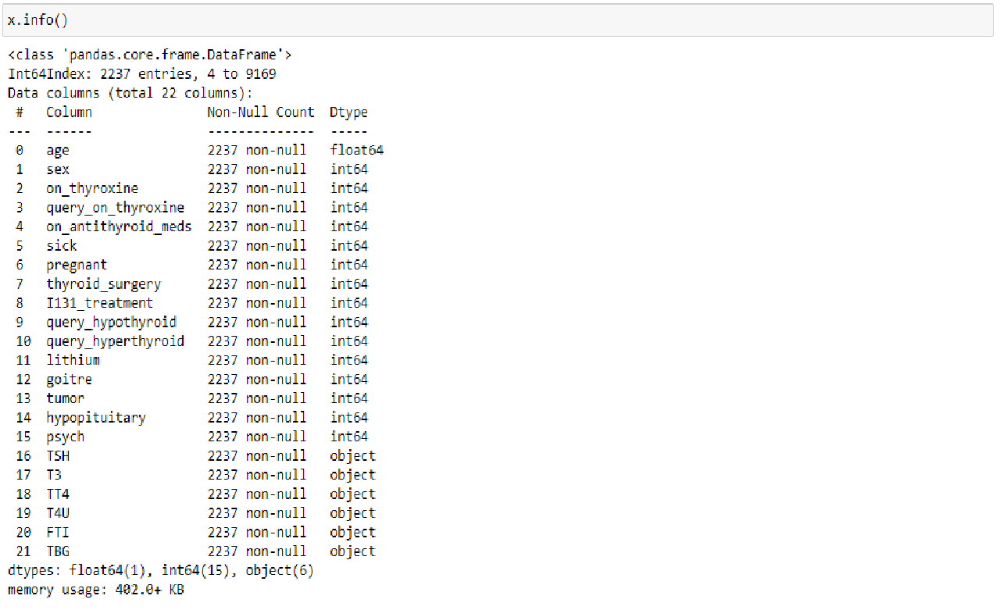

**Handling Categorical Values**

As we can see our dataset has categorical data we must convert the categorical data to integer encoding or binary encoding.

To convert the categorical features into numerical features we use encoding techniques. There are several techniques but in our project we are using Ordinal Encoding and Label Encoding.

* In our project, categorical features are x and y values.
* Here, applying Ordinal Encoding on x values.

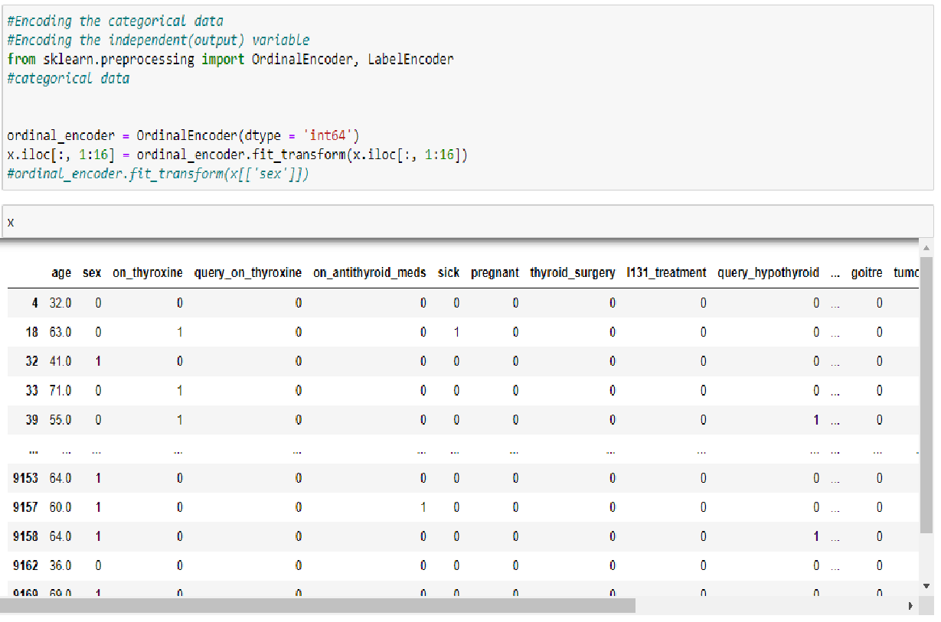

Replacing the nan values with zero (0) values.

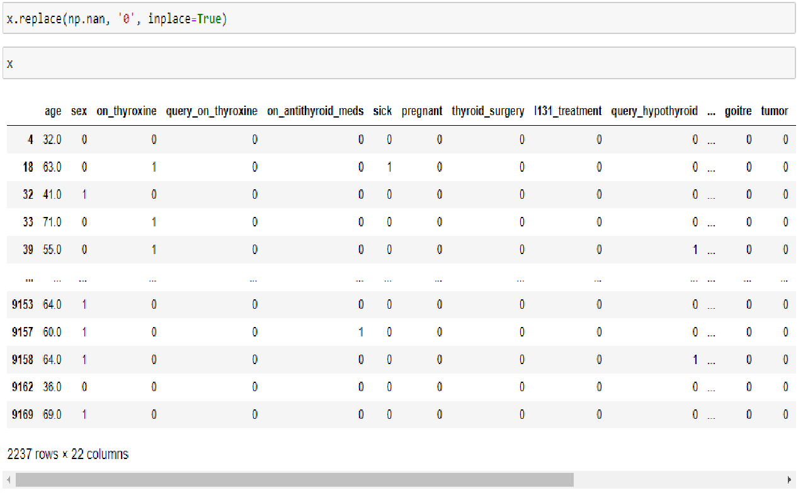

Now, applying Label Encoding on y(Independent variable) value.

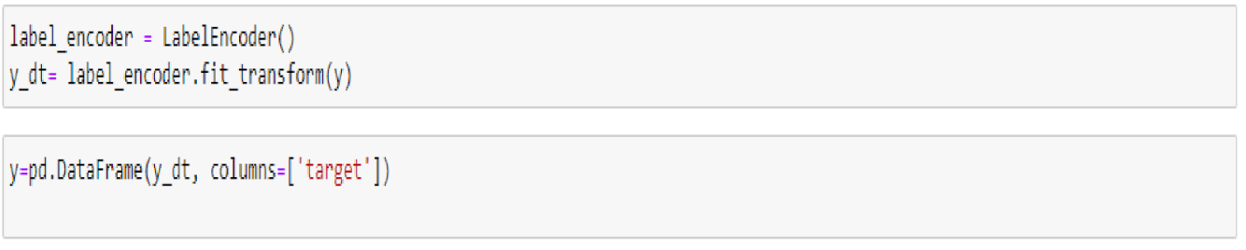

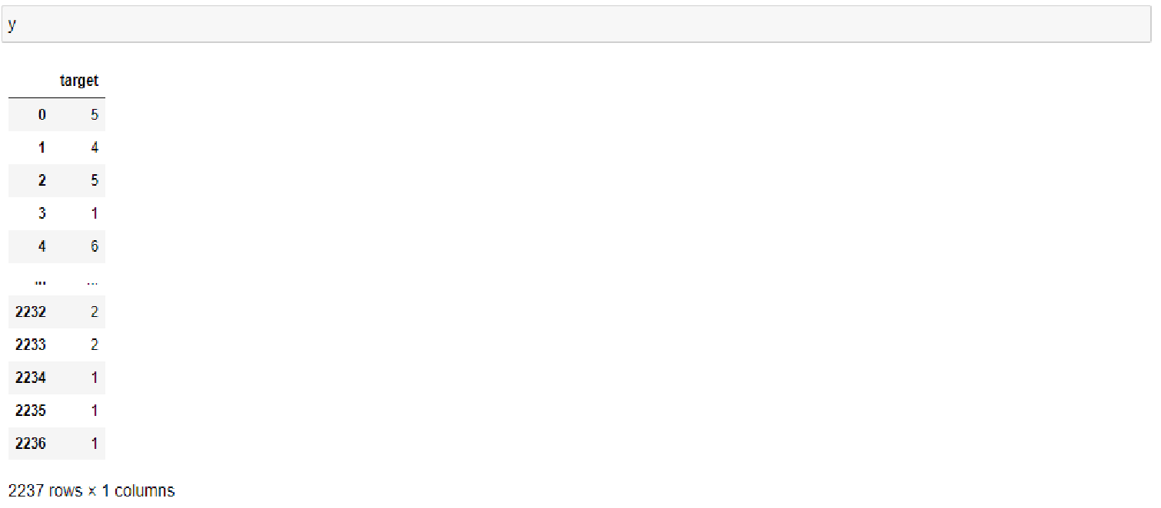

**Exploratory Data Analysis**

In this milestone, we will see the exploratory data analysis.

**Descriptive Analysis**

Descriptive analysis is to study the basic features of data with the statistical process. Here pandas have a worthy function called describe. With this described function we can find mean, std, min, max and percentile values of continuous features.

Checking info about data by using data_info()

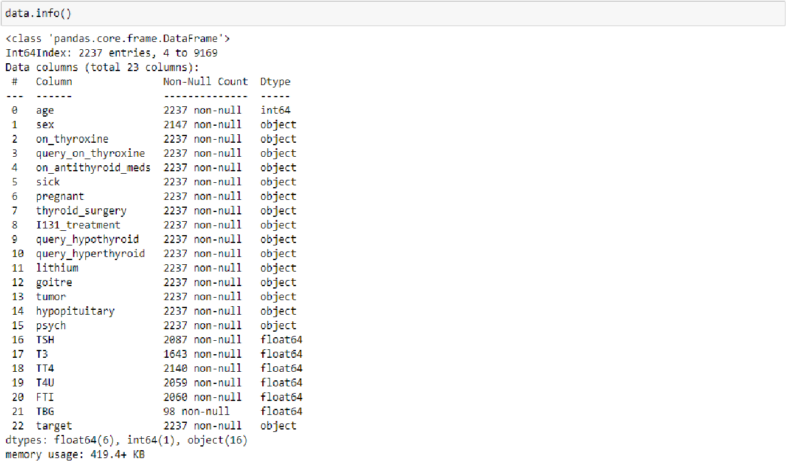

**Visual Analysis**

Visual analysis is the process of using visual representations, such as charts, plots, and graphs, to explore and understand data. It is a way to quickly identify patterns, trends, and outliers in the data, which can help to gain insights and make informed decisions.

**Training The Model In Multiple Algorithms**

Now our data is cleaned and it’s time to build the model. We can train our data on different algorithms. For this project we are applying four  classification algorithms. The best model is saved based on its performance.

**Random Forest Classifier Model**

A function named Random Forest Classifier Model is created and train and test data are passed as the parameters. Inside the function, the Random Forest  Classifier algorithm is initialized and training data is passed to the model with the .fit() function. Test data is predicted with the .predict() function and saved in a new variable. For evaluating the model, accuracy_score and classification report is done.

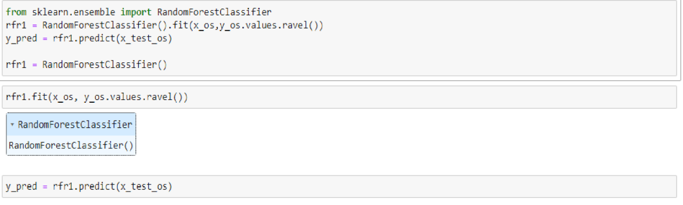

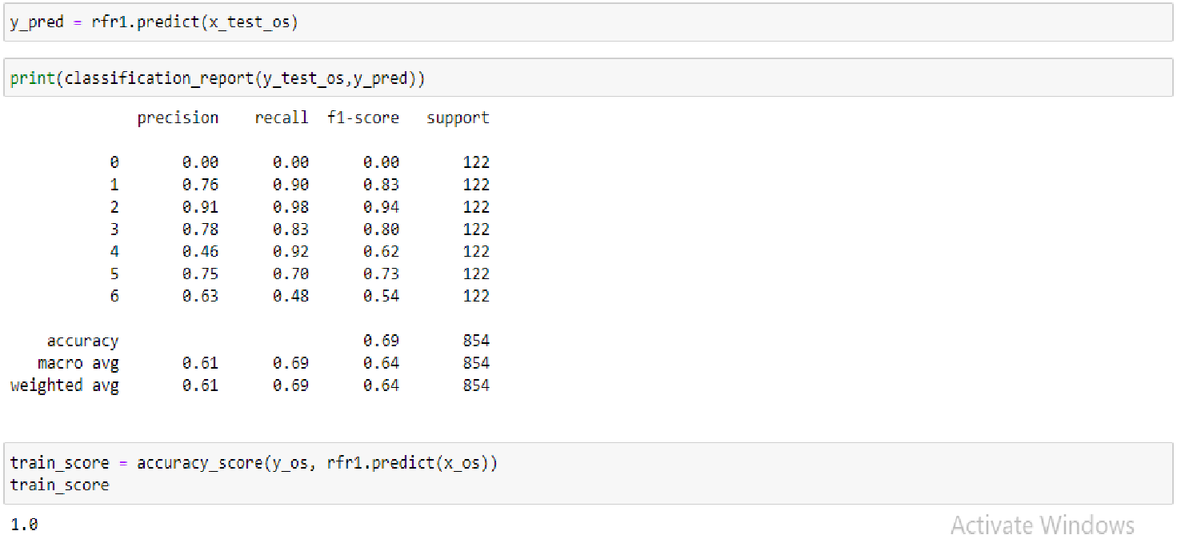

**Building Html Pages**

For this project create three HTML files namely

* home.html
* predict.html
* submit.html

and save them in the templates folder.

Let’s see how our home.html page looks like:

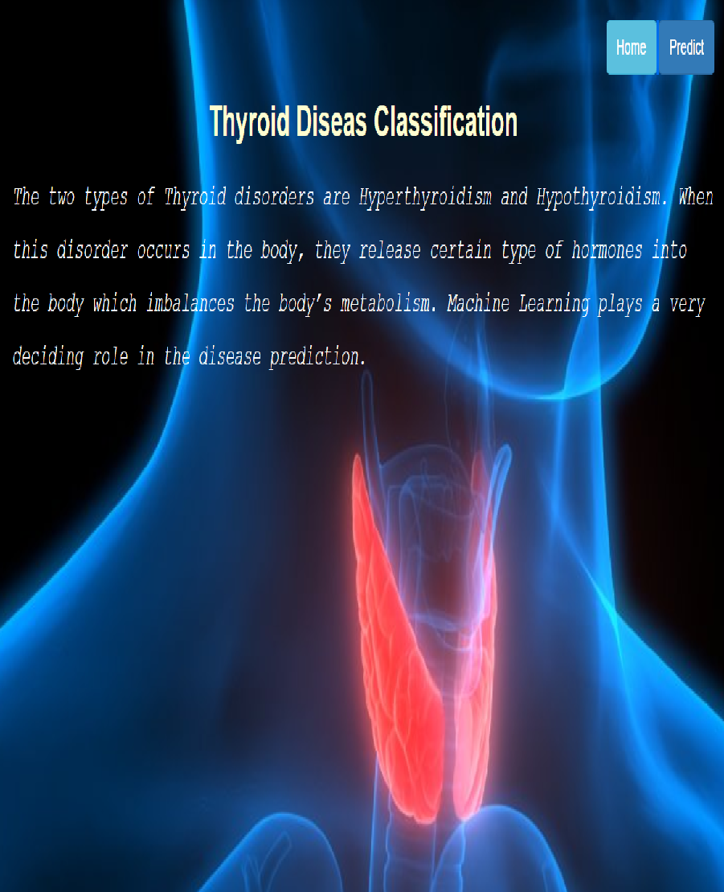

Now when you click on predict button from top right corner you will get redirected to predict.html

Let's look how our predict.html file looks like:

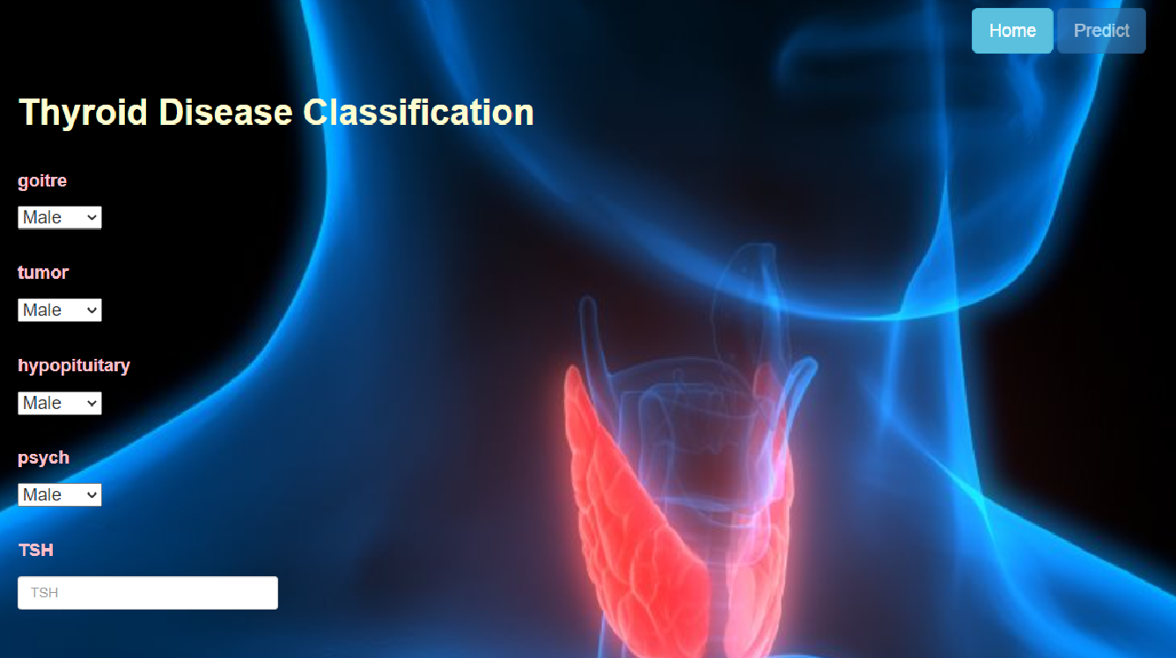

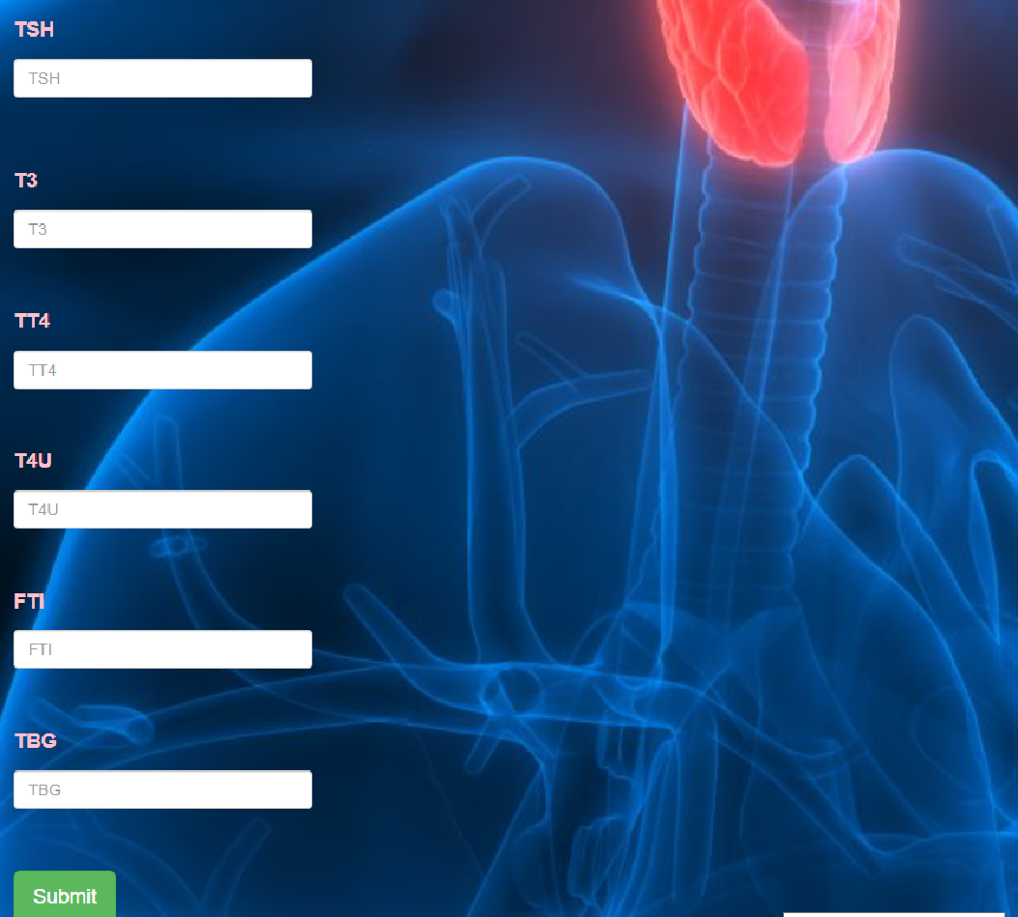

Now when you click on submit button from left bottom corner you will get redirected to submit.html

Let's look how our submit.html file looks like: it is ['miscellaneous'].

